if((i+j+k)%2==0)

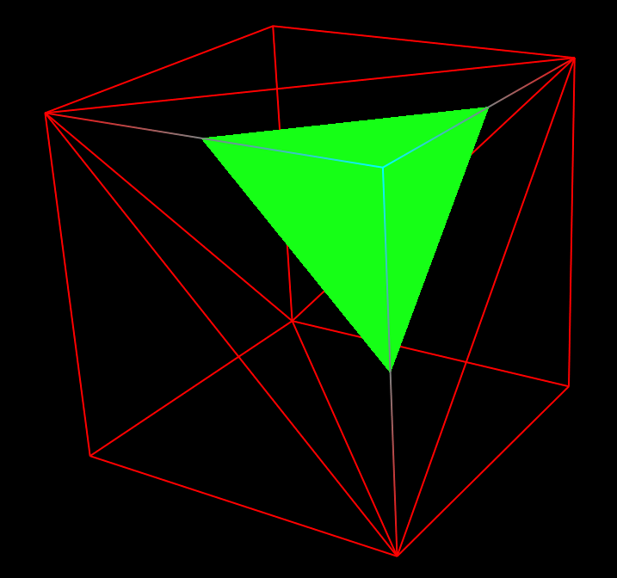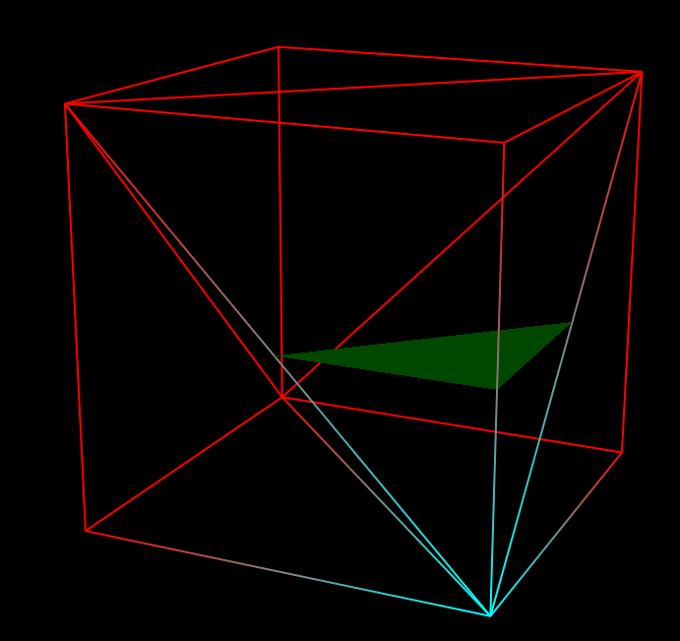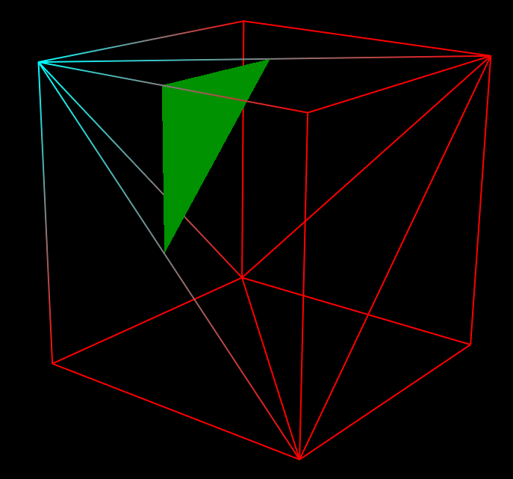

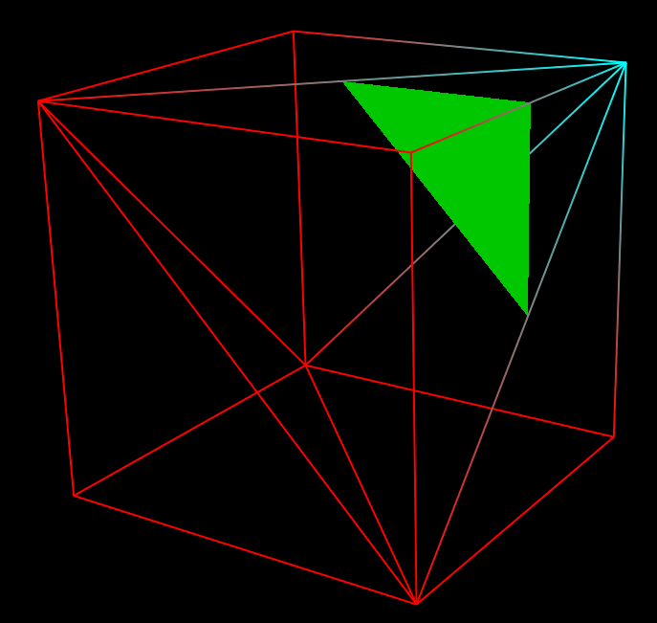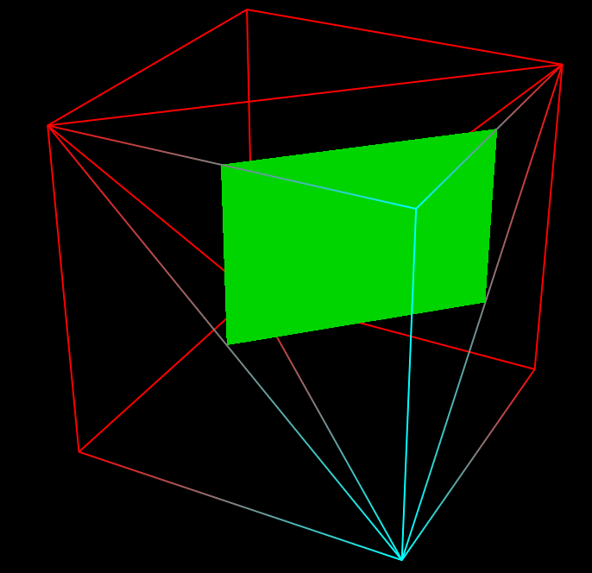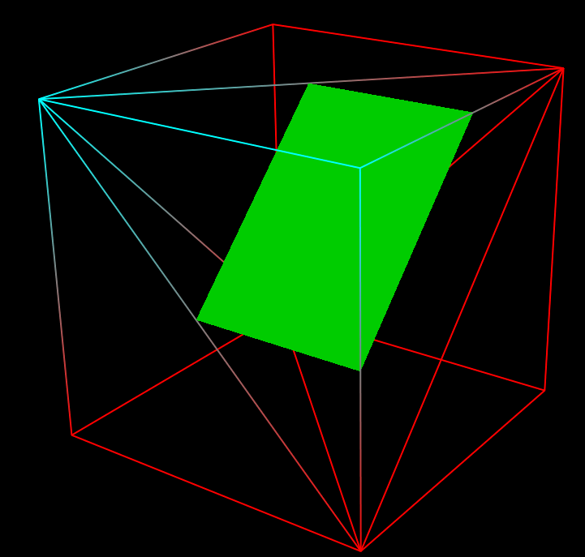

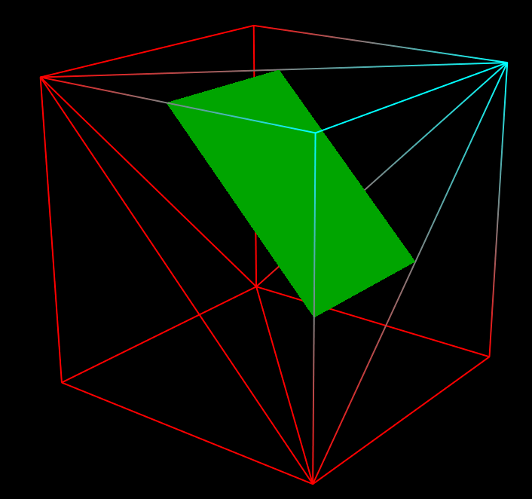

**if(upEdgeCoordinateIndices[k+1][i+1][j]!=-1&&leftEdgeCoordinateIndices[k+1][i][j+1]!=-1&&frontEdgeCoordinateIndices[k][i+1][j+1]!=-1)c+=6;**

**elif(frontEdgeCoordinateIndices[k][i+1][j+1]!=-1&&frontCenterEdgeCoordinateIndices[k][i+1][j]!=-1&&leftCenterEdgeCoordinateIndices[k][i][j+1]!=-1)**

**elseif(frontCenterEdgeCoordinateIndices[k][i+1][j]!=-1&&upEdgeCoordinateIndices[k+1][i+1][j]!=-1&&upCenterEdgeCoordinateIndices[k+1][i][j]!=-1)c**

**elseif(leftEdgeCoordinateIndices[k+1][i][j+1]!=-1&&leftCenterEdgeCoordinateIndices[k][i][j+1]!=-1&&upCenterEdgeCoordinateIndices[k+1][i][j]!=-1)c+**

**elseif(upEdgeCoordinateIndices[k+1][i+1][j]!=-1&&leftEdgeCoordinateIndices[k+1][i][j+1]!=-1&&leftCenterEdgeCoordinateIndices[k][i][j+1]!=-1&&frontCenterEdgeCoordinateIndices[k][i+1][j]!=-1)c+=12;**

**elseif(leftEdgeCoordinateIndices[k+1][i][j+1]!=-1&&frontEdgeCoordinateIndices[k][i+1][j+1]!=-1&&frontCenterEdgeCoordinateIndices[k][i+1][j]!=-1&&upCenterEdgeCoordinateIndices[k+1][i][j]!=-1)c+=12;**

**elseif(frontEdgeCoordinateIndices[k][i+1][j+1]!=-1&&upEdgeCoordinateIndices[k+1][i+1][j]!=-1&&upCenterEdgeCoordinateIndices[k+1][i][j]!=-1&&leftCenterEdgeCoordinateIndices[k][i][j+1]!=-1)c+=12;else b++;**